Article
Resident Power Progressions
Ivis García ¹*, and Mark Chupp²
¹ University of Utah 1; ivis.garcia@utah.edu
² Case Western Reserve University 2; mark.chupp@case.edu
* Correspondence: ivis.garci@utah.edu
Received: date; Accepted: date; Published: date
Abstract: Community developers have discussed how community engagement can be a way of individuals and communities to act. This article will look closely at five power ladders (1) Sherry Arnstein’s “Ladder of Citizen Participation,” (2) the South Lanarkshire Council’s “Wheel of Participation,” (3) the International Association of Public Participation (IAP2) “Public Participation Spectrum” (4) the Asset-Based Community Development (ABCD) Institute’s “Citizen Power Ladder” developed by Jody Kretzmann and John McKnight, (5) Deborah Puntenney’s “Resident Power Progression” and, (6) “Residents and their Associations: A Power Ladder” developed by Jody Kretzmann, John McKnight, Sarah Dobrowolski, and Deborah Puntenney. This article has been the first one to put together the different conceptualizations to achieve resident power developed by the various faculty members at the Asset Based Community Development (ABCD) Institute. After comparing and contrasting the ABCD framework with three other very popular public participatory tools we can conclude that one of the main differences is that ABCD contests the structure of marginalization by transforming the language of individuals and social groups from victims or clients to producers and advocates for change.
Keywords: community development; community engagement; asset based community development

1. Introduction
The field of community development addresses multiple and intersecting levels of marginalization, which might include socioeconomic status, race, ethnicity, gender, sexual orientation, ability, religion, citizenship status, and other characteristics associated with unprivileged social situations

[-]. Although most of community development work condemns, and rightfully so, structural dimensions of society such as racism, xenophobia, homophobia, ageism, classism, sexism, and other forms of intolerance, it falls short in offering those who have experienced differential treatment a way of acting [-]. In other words, once people are labeled as being in the margins (e.g., as homeless, disabled, old, etc.), there is a minimal conversation among policymakers, practitioners, academics, and others who spend their lives in the world of institutions about people’s agency [-].
The problem is that once people are viewed through the prism of marginalization, it is all too often internalized and therefore difficult for them to see how can they can contribute [-]. The nature of marginalization establishes who is and who is not inside the circle, who can contribute and who cannot [-]. Even the term citizen, which holds the promise of agency for the common person, is divisive and has come to exclude people based on legal status [9,-]. Those who are kept at the margins of society or community have been demoralized, losing self-confidence and hope for the future [-]. When people are treated as victims or clients; when they are not given a choice to be producers, their confidence is destroyed [-]. What is more, demoralization fosters an environment of self-doubt and anxiety [].
If this is the case, then, how can individuals and groups that have been conceptualized as being in the margins of society enter a space of contribution when their problems and needs are constantly amplified? There are two paths for developing the space where everyone is valued as an active contributor to the community. One focuses on the process. What are processes that promote participation by everyday people (often called citizens or residents) in decisions that affect their lives [-]. The other focuses on the individual and their role. What are practices that work with everyday people to increase their agency (voice, power) in public decision-making? [-].
The process for everyday people to participate in community decision-making, especially when directed by public institutions or elected officials, is notoriously disempowering [-]. The common process known as D.E.A.D. (decide, educate, announce and defend) happens all too common []. First, according to Hartz-Karp (2007) a small group of influential stakeholders “Decide” (D) behind closed doors what the future of a public project will look like and begin the planning process. Second, these leaders begin to “Educated” (E) the community on the need for the project and provide a rationale for the yet disclosed plan. Third, those in power “Announce” (A) the plan that has already been decided and partially or fully planned out. Finally, with an understandable reaction and/or rejection by the community of the plan, the leaders “Defend” (D) the decision. Needless to say, the process forces community members into a reactionary mode, their best ideas and contributions are not included, and as a result, the plan often misses the mark.
In this context, it is essential that we be clear about our intentions when conceptualizing community participation []. There is a continuum of ownership by the community that we seek to achieve through the process, but at a minimum, community engagement is “a planned process with the specific purpose of working with identified groups of people, whether they are connected by geographic location, special interest or affiliation, to address issues affecting their well-being” []. Ladders or participation, then, provide levels of voice or agency in those decision-making processes.
Turning to the roles individuals play in community development, Asset-Based Community Development (ABCD) emphasizes the creation of policies and activities involving the capacities and skills of neighborhood residents []. ABCD comes from the recognition that the development of an entire community can only take place if residents can invest their gifts and themselves in the process. Instead of depending entirely on outside resources and charity, ABCD establishes that it is better to start the process of development from within the community—that is, from the inside out [12]. This truth has been recognized much earlier by neighborhood leaders than by researchers and social service providers. The efforts dedicated to the development of the community will be successful only if there is a clear understanding of the internal assets and capabilities of the community. Connecting all local assets of the neighborhood is an essential step towards rebuilding communities. This does not imply that non-profits, foundations, and universities should abandon communities, and residents need to do everything themselves. What it does say is that, if we are intentional in building communities from the inside out, power will multiply. Community development from the outside is not sustainable.
An inclusive approach would require institutions to recognize the contributions of individuals and citizen groups to not act as an obstacle to the progression of community control. This would require the institution to promote participation by considering how citizens can become producers. A professional working in institutions need to be very careful about reproducing marginalization. Inclusion is about changing attitudes about disadvantage, helping communities in overcoming their exclusions.
Often the concept of how poor communities can be empowered is left to institutions. Institutions empower and disempower individuals and communities. Nonetheless, the idea of how communities can enable themselves to achieve community control is frequently not theorized. Theorization that aid individuals, associations as well as institutions to act are particularly needed. There are certain functions of community well-being that institutions are not effective in providing, that only can be achieved when individuals come together and form associations. This article is an opportunity for practitioners to reflect on how engagement can be transformed into citizen power.
Our discussion is organized in the following manner. First, we present several power conceptualizations that practitioners have used in their work on public process, such as Sherry Arnstein’s “Ladder of Citizen Participation,” the South Lanarkshire Council’s “Wheel of Participation,” and the International Association of Public Participation (IAP2) “Public Participation Spectrum.” Second, we discuss the Asset-Based Community Development (ABCD) Institute’s “Citizen Power Ladder” developed by Jody Kretzmann and John McKnight. We also present two additional ABCD ladders—one produced by Deborah Puntenney the “Resident Power Progression” and one developed by Jody Kretzmann, John McKnight, Sarah Dobrowolski and Deborah Puntenney “Residents and their Associations: A Power Ladder.” In the discussion, we compare the levels of participation and agency that each of these ladders provide. We then discuss the implications of the “Citizen Power Progression” and also advocate for a space of inclusion for those that have been left at the margins of community.

2. A Review of Power Ladders, Wheels, and Spectrums
Community developers have discussed how community engagement can be a way of individuals and communities to act. Community engagement has been conceptualized as a (1) ladder (e.g., Sherry Arnstein’s Ladder of Participation, figure 1), (2) wheel (e.g., South Lanarkshire Council’s, figure 2) and, (3) spectrum (e.g., International Association of Public Participation, figure 3) with levels of increasing participation. Each level increases the degree of citizen control and, thus, the empowerment of those who actively seek to participate in community work.

2.1 Sherry Arnstein’s Ladder of Citizen Participation
By the late 1960s, Sherry Arnstein (1969), who worked as an assistant to the U.S. Department of Housing (HUD) secretary at the time, embraces the concept of Model Cities. The cities chosen such as Detroit (Michigan), Atlanta (Georgia), and Hato Rey (Puerto Rico) were studies as case studies of mixed-income communities where advisory committees would lead development and investments. Arnstein presented what she called the “Ladder of Citizen Participation,” each step moved toward more authentic engagement—from manipulation to citizen control (see figure 2) [].

2.1.1 Manipulation
Citizens are educated about the issues with a pre-determined staff recommendation. People are expected to agree with the staff recommendation because studies already being made, and the most rational conclusion already has been achieved.

2.1.2 Therapy
The purpose is to listen to people’s grievances patiently, like a therapist. You are assuming that nothing can be done about the issue at hand, but that at least a meeting could be a space for ranting.

2.1.3 Informing
This is the first step into tokenism. Citizens are informed of the process, issues, plans, etc. but are not consulted. At this stage, there is no feedback from the public.

2.1.4 Consultation
Citizens are consulted via surveys, focus groups, public meetings, etc. This is limited engagement because the public is not making decisions; they are just consulted for the information they can provide to experts.

2.1.5 Placation
Some citizens are picked as a token to become part of advisory committees and boards. This gives more legitimacy to power holders, who are not yet willing to share their power.

2.1.6 Partnership
Partnerships are the first step toward redistributing power between citizens and power holders. Decision-making is shared thought negotiation and deliberative processes.

2.1.7 Delegation
Citizens are trusted to make their decisions. They are in charge of entire programs and budgets within a project or organization.

2.1.8 Citizen Control
Citizens might use experts for technical assistance, but they are ultimately in control of all the planning and funds; they have started their community development corporations.
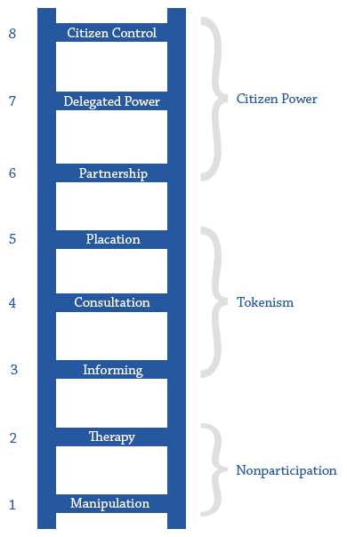

Figure 1. Sherry Arnstein’s Ladder of Citizen Participation
Arnstein’s ladder has come to be seen as indispensable for sociologists, geographers, urban planners, public administrators, and healthcare providers, to mention a few, trying to conceptualize the processes and means they might use to engage communities. Ideas for community change need to come from the interests, desires, and needs of people within those communities, with planners playing a listening and facilitating rather than a prescriptive role. This means planners have the task of not only planning for communities but also with them.

2.2 South Lanarkshire Council’s Wheel of Participation
The South Lanarkshire Council, which is a unitary authority in Scotland, took as a basis Sherry Arnstein’s Ladder of Participation and revised it into a “Wheel of Participation” []. The wheel is divided into four quadrants: (1) information, (2) consultation, (3) participation, and (4) empowerment. The wheel then goes from people being told what is being done by the Council to people taking important decisions that affect South Lanarkshire. The four quadrants and each subcategory, for a total of 12 categorizations, are described below (see figure 3).

2.2.1 Information
In the “minimal information” (1.1) category, the South Lanarkshire Council provides some information which it could be online or via public hearing. There is no actual consultation of the public, although the public might give some comments. These comments might be recorded in the meeting minutes, but the Council takes the decision. 1.2. “little info” is when the Council might provide plans and documents for the public, and the public might ask questions. However, the Council might answer questions superficially because the Council has an administrative decision. 1.3 “high-quality information” is when the Council dedicates time and resources to answer the questions that the public has about X, Y, Z issue.

2.2.2 Consultation
“Limited consultation” (2.1) provides information in a limited manner that allows communities to respond. For example, the Housing Authority in Puerto Rico might place a notice on their website or the newspaper saying that they are accepting comments for their Substantial Amendment to the Puerto Rico Disaster Recovery Action Plan 2.2. “Customer care” might occur when the public has a mechanism to complain about an issue. As an example, the City might send a notice to all homeowners living within a mile of a new site that is being developed for construction. Homeowners then might have the opportunity to send a letter to the staff planner in charge of that site development; they could also attend a public hearing on the topic. 2.3. “Genuine consultation” is when the Council seeks out the community’s opinions before any action is taken place. Members of the Council might assemble a survey of the neighborhood to understand the needs and wants in that community.

2.2.3 Participation

“Effective advisory body” (3.1) is the act of inviting communities to come up with their proposals. Members of the Council could carefully consider these proposals. 3.2. “Partnership” is to solve problems with the district. In this case, the Council would partner with community leaders and their associations, non-profits, or other institutions, being schools, libraries, etc. to plan together. 3.3. “Limited decentralized decision-making” is allowing community councils, neighborhood, chambers of commerce, or other groups to make their own decisions in regards to projects such as traffic calming in a neighborhood or placemaking and branding efforts a commercial district.

2.2.4 Empowerment
“Delegated control” (4.1) is delegating limited decision-making powers in a neighborhood. For example, homeowners might decide to collect extra fees and form a homeowner association to develop a new park in the area. 4.2. “Interdependent control” is when the Council facilitates residents into forming an association, anon-profit or business to take on a service that is needed (e.g., picking up the recycling, planting trees, cutting grass, and taking care of public landscaped areas, etc.). Finally, “entrusted control” (4.3) is the act of giving back to residents and the community decision-making powers. For example, the community might be given $1 million from taxes and might vote on what they would like to see.

Participatory Planning

4. Empowerment
4.1 Delegated Control
4.2. Independent Control
4.3. Entrusted Control

1. Information
1.1. Minimal Info.
1.2. Little Info.
1.3. High-quality Info.

2. Consultation
2.1 Limited Consultation
2.2. Customer Care
2.3. Genuine Communication

3. Participation
3.1. Effective Advisory Body
3.2 Partnership
3.3. Limited Centralized Decision-Making
Figure 3. Adaptation of South Lanarkshire Council’s Wheel of Participation. Source: Ivis García.

The South Lanarkshire Council “Wheel of Participation” in a way is more similar to the International Association of Public Participation (IAP2) “Public Participation Spectrum” because it asks what the Council is trying to achieve based on a particular project at hand. Then it decides as to which quadrant and strategy would be appropriate. The wheel recognizes that in some instances, the public might not be involved at all—a project could be information-only. The next section discusses the (IAP2) Public Participation Spectrum.

2.3 IAP2 Public Participation Spectrum
The International Association of Public Participation (IAP2) “Public Participation Spectrum” helps planners pair their own community engagement needs with a level of public participation (see Figure 4). The first row in the figure shows a goal statement for public participation, so everyone shares a common understanding of the extent to which the community will be engaged according to what is needed in the planning process [23,25]. The second row is an example of a particular technique that will aid that goal. The spectrum is composed of five categories: inform, consult, involve, collaborate, and empower.

2.3.1 Inform
The first level in a spectrum is to inform the community. This step does not provide the public with an opportunity to participate; it is something conceived of and orchestrated by decision-makers.

2.3.2 Consult
While the informing stage is a precursor to public participation, the consultation phase is an entry point for public participation in the processes moving forward. For example, surveys are a great way to consult with residents on issues that affect them.

2.3.3 Involve
Methods of involving community members in the decision-making process, such as through the charrette technique, move the planning process from merely informing and consulting with community members to include them in the process.

2.3.4 Collaborate
Collaboration with community members provides an opportunity for community members to secure ownership over the planning process and its outcomes, which can aid in practical implementation.

2.3.5 Empower
The final level in the spectrum is for decision-makers to empower communities to make their own decisions on issues that affect their lives.

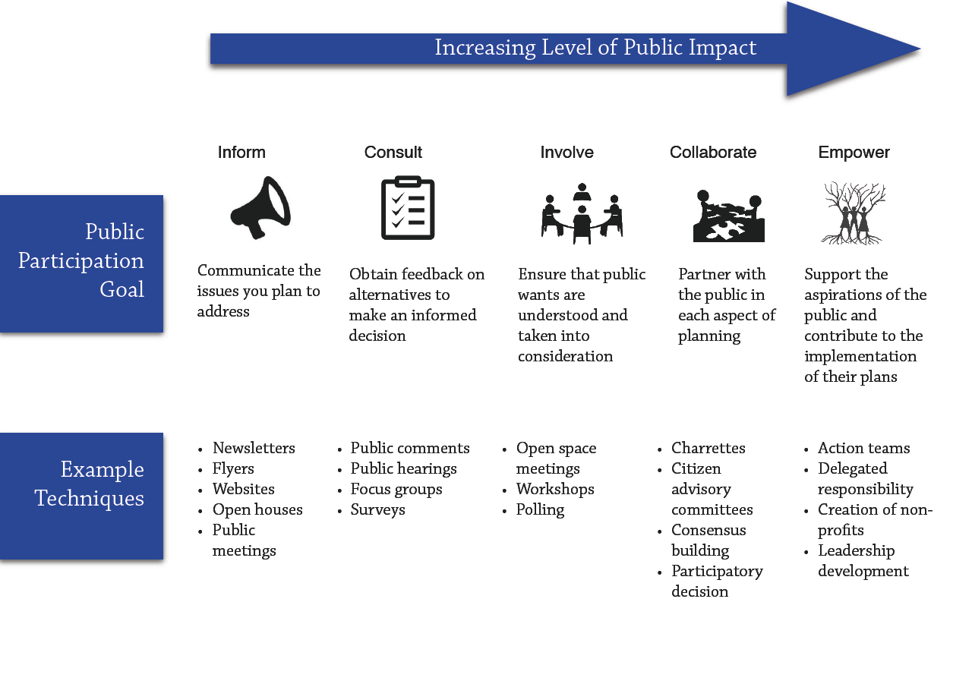

Figure 4. The spectrum of Public Participation. Adapted from the International Association of Public Participation. Source: Ivis García.
Compared to Arnstein’s Ladder, the IAP2 doesn’t include manipulation and therapy. The levels start at inform. Empowerment in the IAP2 is similar to the delegation and citizen control in the Arnstein’s ladder. The spectrum is from the perspective of the decision-makers and not citizens. Ideally, a practitioner would start by “informing” and then move towards achieving “empowerment” for an increasing level of public impact.

3. Asset-Based Community Development Institute Power Ladders
This article will discuss in more depth the Asset Based Community Development Power Ladder, developed by Jody (Jody) Kretzmann and John McKnight, the ABCD Institute (figure 5). There are other ladders produced by ABCD’s faculty, which will be presented as well. For example, the one developed by Jody Kretzmann and John McKnight with Sarah Dobrowolski and Deborah Puntenney (figure 6) was developed by Deborah Puntenney (figure 7).

3.1 Jody and John’s Citizen Power Progression
The “Citizen Power Progression” which comes from the “ABCD basic slides” posted on the ABCD Institute website shows how the individual can increase their participation and improve their community. To the author’s knowledge, the “Citizen Power Progression” is recently used in verbal presentations, but it has not been used in a publication. The progression identifies five positions that a citizen could take: (1) victim, (2) client, (3) advisor, (4) advocate and, (5) producer (see figure 5).

3.1.1 Victim
A victim, by necessity, is a recipient. It might be of violence, discrimination, or life circumstances. However, the word ‘victim’ has very negative connotations. The word communicates a deficiency, powerlessness, and incompetence []. This is why people do not necessarily define themselves directly as victims. In the narratives of young men who have experienced violent acts, interviewees tended to downplay vulnerability and claim responsibility because they did not want to present themselves as weak []. A similar study found that young men had “a desire to be portrayed as a competent and strong individual and not as a victim” []. According to the authors, these young men did not reject having a victim’s identity, but they modified it to show their strengths as individuals.
Many studies show that individuals tend to reject victim narratives while simultaneously putting forward these narratives; they combine what seems like contradictory identities. This is because having a self-image of being a victim can be extremely damaging to an individual. Calling oneself a victim could result in further marginalization, instead of overcoming the experienced that resulted in exclusion. People are generally reluctant to fit the identity of victims, to put a label on themselves. Yet, individuals are discursively produced as victims frequently by institutions, who put these labels on people.
ABCD shifts the perception of being a victim or being marginalized to make space for engaging politically. Victimization creates shame, and people tend to denigrate themselves. Self-blame could result in people hiding from the community. This “also leads concerned outsiders into becoming charitable ‘fixers’ [16]. Outside institutions generally perceive people in communities as helpless and dependent on them. Studies have shown that institutions with altruistic behavior are more willing to invest their time and effort if they believe that dependency is externally caused. In other words, dependency is legitimate. Other research suggests that those who showed high levels of dependency received the most frequent help. Yet, dependency is “not the most effective relationships for enabling long-lasting change” [16]. Dependency has sociopolitical roots in colonialism, soft-forms of power and oppression. Those who foster dependence, most likely inadvertently, become a barrier for individuals and communities to become agents of change.

3.1.2 Client
It used to be that people in neighbors helped each other. With the growth of social services, neighbors needed each other less and less. There is a whole system of social service provision. Where “care” is outsourced to those, who are paid to “care.” John McKnight argues that service systems cannot produce care. They can provide services such as education, health, etc. People in those institutions can care, but not the institution itself. In a way, social service organizations have stolen the notion of care and it says that the system can produce care. But care is not something that can be managed, it can be given and growth from connection. No system can ever deliver care.
Social service system depends on clients, they serve clients, and they are paid to serve clients. The relationship that is created here is social service: client. A client is someone who is characterized by their needs—people who need health care, education, housing, etc. Clients are waiting to receive services [16]. They are in a passive role of receiving services, and they are not asked to give back. Clients are pretty much always in a position of consumption and not production. This means that this relationship is not based on reciprocity. A neighborly relationship would be based on this promise but not a client: social service relationship. The relationship is not one of co-production but one of co-dependency. The social service organizations get paid if the client receives the service. ABCD questions whether a relationship between a client and a social service provider can result in empowerment.

3.1.3 Advisor
Above from residents being clients of social service organizations is the role of being “advisors for institutional action” []. Organizations can ask themselves if they have neighborhood people on their board of directors, advisory groups, or committees? Coincidentally, these advisors could be clients that can help the organization bring the clients’ perspective into the decision-making process. Clients could be given the opportunity of sharing their gifts and talents (e.g., fundraising, facilitation, advocacy, marketing, etc.) with the board of the organizations. This strategy is required of most Community Development Organizations (CDCs), where at least one-third of the board and most time half of the board are composed of neighborhood residents. This ensures that their interest is represented within the organization. Many CDCs have a leadership arm to make sure that community organizing occurs in the neighborhood and that some of these residents can join the board. More progressive organizations will choose Chairs of the board or committees and even executive director of organizations residents from the community.

3.1.4 Advocate
Many organizations partner with residents for advocacy goals. For example, an organization that builds affordable housing might include in the Housing Committee tenants, community leaders, and so on, and they might advocate in the city, state or even national level on housing policies that affect them. Advocacy involves the organizations and the residents taking decisions together and co-creating press releases, policies, apply for grants, etc., to implement a project that they come up with together. If the project is funded or successful, this would entail a dedicated space from the community in the new building or residents being hired in the project. In more progressive instances, residents would seek the partnership of different organizations in their community to make their own projects happen. Those who foster dependence, most likely inadvertently, become a barrier for individuals and communities to become agents of change [].

3.1.5 Producer
Participation should not be about passively making decisions as a technical exercise (e.g., saying yes or no as a board member but not engaging in a real effort to build a better community). A lot of discussions have gone to talk about democracy in a very shallow manner. One’s right to vote. Another strand of work is concerned with capacity building and the transformation of oneself and one’s community. When one becomes a producer, one starts creating opportunities for empowerment. Producers engage in the act of redistributing power to non-elite groups because they have power themselves. A producer not only claims its rights, but they create rights for others. They also take responsibility. Producers participate, and thus, they can benefit from their participation. They set up a vision of the future and benefit from the outcomes. Producers work in implementation. Producers challenge unjust structures. Finally, producers work with organizations to co-producer with them on their own and their community well-being.
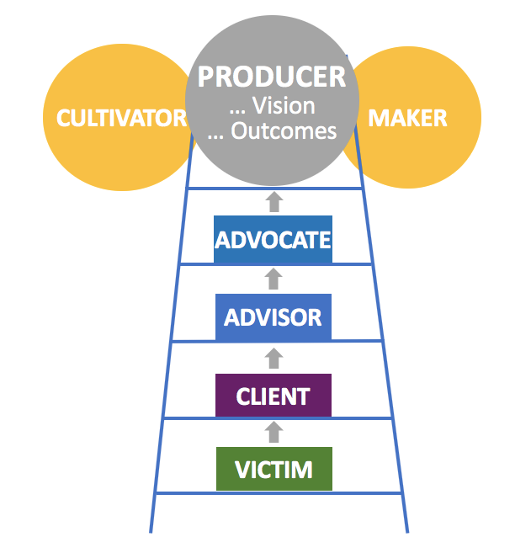
Figure 5. Jody Kretzmann and John McKnight ABCD “Citizen Power Progression.” Source: ABCD Institute basic slides.

3.2 Deborah Puntenney’s Resident Power Progression
Deborah, is Emeritus Associate Professor from the School of Education and Social Policy at Northwestern University and the Asset Based Community Development Institute, created the “Resident Power Progression” shown in figure 6 to illustrate how engaging people as authentic actors can facilitate change. She used the ladder in her own presentation slides and to the author’s knowledge they never have been published. At the bottom of the ladder, there is category “victim,” just like in Jody and John’s Citizen Power Progression. This ladder takes out “client” in order to make it more relevant to organizations that might not have clients and goes straight to the “advisor” category. Instead of “advocate” Deborah uses “participant” followed by “actor/ producer” (similar to John and Jody’s ladder). Dr. Puntenney moves “advocate” to the top of the ladder.

3.2.1 Victim
A victim can refer to someone that has been victimized, but it can also be a role people adopt. In our society, many people have been victimized, and we need to change the systems and policies that allow that to happen. But when people give up, and adopt the role of victims, this puts them in a powerless place because victims never have power. Dr. Puntenney notes that one the goals of ABCD is to move people out of that role and into increasingly sophisticated levels of engagement.

3.2.2 Advisor
Moving up the ladder, Dr. Puntenney emphasizes the role of advisor, which can be good or bad. While advisor is a role people want to take, the advisor role can be an empty one, for example when an institution sets up a community advisory board, but gives board members no power. Authentic advisors have some kind of decision-making authority.

3.2.3 Participants
The next level, participant, an entry-level role. Participants get involved but don’t generally contribute to defining the vision or implementing it.

3.2.4 Actor/producer
An actor/producer is a critical role because it means people have stepped up and feel the confidence & capacity to change some part of their world.

3.2.5 Change advocate
Finally, the most sophisticated role is change advocate. This is a person who is an actor/ producer, but goes beyond that to work to change the systems and policies that support residents.

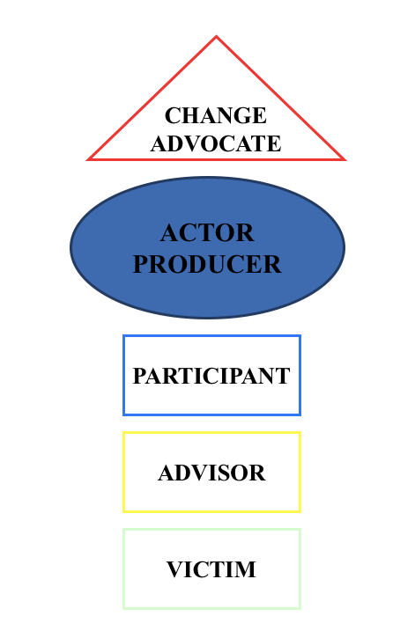
Figure 6. Deborah Puntenney’s “Resident Power Progression.” Source: ABCD Institute.

3.3 Residents and their Associations: A Power Ladder
This ladder appeared first in a report funded by the Kellogg Foundation in 2005 titled, “Discovering Community Power: A Guide to Mobilizing Local Assess and Your Organization’s capacity.” The authors of the workbook were John P. Kretzmann, John L. McKnight, Sarah Dobrowolski, and Deborah Puntenney [27]. The “Residents and their Associations: A Power Ladder” has four rungs residents as: (1) recipients, (2) information sources, (3) participants and, (4) in control (see figure 7). The overall goal of the ladder is for institutions to start seeing residents not as clients or recipients of aid, but as full contributors to the community-building process [27].

3.3.1 Residents as recipients
Clients are passive recipients of services. Similarly, residents in neighborhoods could be treated the same way.

3.3.2 Residents as information sources
Most organizations often need to gather information from residents. A common example, is the use of surveys by community based or government organizations.

3.3.3 Residents as participants
Community based organizations are rooted in place and have extensive contacts and information about the neighborhood. Their primary mission is aimed at the community; they emphasize the importance of place over other goals by having listening conversations with neighbors, community leaders, and associations.

3.3.4 Residents in control
The goal of ABCD is that institutions see communities as “co-producers of health and well-being, rather than the recipients of services” []. In more progressive examples, community-based organizations could be controlled by local residents through the board or having a real say in the organization’s policies and programs []. Another way to exert community control is by obtaining positions within organizations as well as organizing their communities towards the goals identified by collaboration among residents.

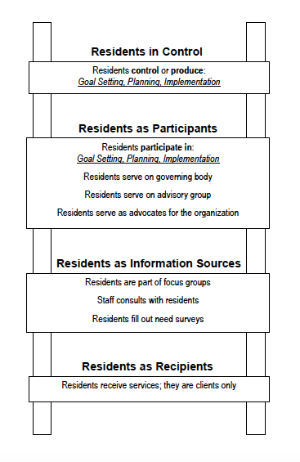
Figure 7. Residents and their Associations: A Power Ladder. Developed by Jody Kretzmann, John McKnight, Sarah Dobrowolski and Deborah Puntenney. Source: ABCD Institute.

6. Discussion: Moving Up the Progression for Greater Empowerment
Some focus on the individual as the unit of analysis. In IAP, the unit of analysis is public process. In community organizing, the unit of analysis is the campaign with different roles individuals play in an effective strategy. In comparing ladders (see figure 8), there are several themes in common. All ladders conceptualize the highest level as empowerment or citizen control, reflecting a commitment to the full actualization of community residents in the development of their community. All ladders convey some form of active participation as more engaging than being consulted, which is more than information sharing.
Differences are also significant. In the process-focused ladders, the lowest level of participation is information sharing, with the Arnstein model dividing informing into nonparticipation, therapy and manipulation. The therapy role would more aptly be termed today as complaining, where a space is created for expression of grievances without avenues for addressing them. In contrast, the lowest level in the individual-focused, ABCD approaches is being a victim. The characteristic of a victim is someone that has suffered some injury or negative action upon them. This goes beyond being a passive person to one of being harmed by the community. One level up from this level, not identified in any of the ladders is a survivor, one who is actively taking steps in their recovery. It does not negate what happens but redefines how the person sees it and the impact it has on them. A thriver would be one step up from survivor who has largely moved beyond recovery to working toward becoming an active participant in community life.
One difference that crosses process and individual-focused ladders is the number of levels or rungs in the ladder. The Arnstein, South Lanarkshire, and the Kretzmann & McKnight with Dobrowolski & Puntenney models all have eight or more steps. The other models provide broader, more general levels that make it more difficult to conceive of a gradual progression, of how people would move from one level to the next.

PROCESS FOCUSED  Non-ABCD |  |  | INDIVIDUAL/ROLE FOCUSED  ABCD
Arnstein | South Lanarkshire Council | IAP2 | Kretzmann & McKnight | Puntenney | Kretzmann & McKnight with Dobrowolski & Puntenney
Citizen Power | Empowerment |  |  |  | Residents in Control
Citizen Control | Entrusted Control | Empower | Producer | Change Advocate | Control goals, planning, & implementation
 | Independent Control | Collaborate | Advocate | Actor/  Producer | Residents as Participants
Delegation | Delegated Control |  |  |  | On governing boards
Partnership | Participation | Involve |  |  | On Advisory boards
Tokenism | Limited Centralized Decision-Making |  |  | Participants | Serve as advocates
 | Partnership |  |  |  | Residents as Information Sources
Placation | Effective Advisory Body |  | Advisor | Advisor | Part of focus groups
Consultation | Consultation | Consult |  |  | Consulted
 | Genuine Communication
 | Customer Care |  | Client
 | Limited Consultation |  |  |  | Fill out surveys
Informing | Information |  |  |  | Residents as Recipients
Non-participation | High Quality Info | Inform |  |  | Receive Services
Therapy | Little Info |  |  |  | Clients
Manipulation | Minimal Info
 |  |  | Victim | Victim
Figure 8. Six Conceptualizations of Achieving Citizen Power and Control. Source: Ivis García & Mark Chupp (Note: Bold italics represent the major rungs on the ladder of particular models)

7. Conclusion
Victimization restricts inclusion. Asset based community development challenges the view that victimization should be reinforced [12, 16, 27, 33]. Even when many community development work comes from the perspective of people being “victims” of discrimination, social and economic disadvantage, once an individual or group is associated with disadvantage it is very hard for others (e.g., teachers, potential employers, social service providers, etc.) to see their human capital (e.g., skills, gifts, capacities, etc.). Not acknowledging one’s human capital is an indirect way of exacerbating the failures of individuals; inability to get a job, an education, raise children with values and so on. The result is then a needs assessment and not a map of individual and community assets.
Although policymakers might see people as suffering from socioeconomic circumstances. They would say they do not blame the victim for their individual actions but place the fault in society as a whole. Yet, these same policymakers are unlikely to take full responsibility for the individual’s future success. This is why the realization of rights can only happen if individuals assume responsibility along with policymakers to create change. This is also why so many authors and organizations have dedicated time and effort to develop power ladders, spectrums, wheels, and progressions. These conceptualizations tools can really help institutions think about their engagement process and the roles they have created for clients and residents, and ultimately, consider how they can facilitate community control and empowerment.
From the perspective of Asset Based Community Development (ABCD) as illustrated from various the Power Progressions and Ladders, institutions (e.g., that is government, non-profit organizations, and businesses) are not the source of empowerment, but rather a space in which the citizen’s gifts may or may not be valued. In this way, the ABCD Power Progressions and Ladders—the “Citizen Power Ladder” developed by Jody Kretzmann and John McKnight, Deborah Puntenney “Resident Power Progression” and the “Residents and their Associations: A Power Ladder” developed by Jody Kretzmann, John McKnight, Sarah Dobrowolski and Deborah Puntenney are similar to the “Ladder of Citizen Participation,” the “Wheel of Participation,” and the “Public Participation Spectrum.”
What all of these ladders, progressions, wheels, and spectrums have in common is that they seek for ultimately the community be the owners of their own destiny by having control and achieve empowerment and self-determination. What is different is how ABCD talks about marginality in a way where the community or individual has no agency, it becomes in itself a structure of discrimination. This article has been the first one to put together the different conceptualizations to achieve resident power developed by the various faculty members at the ABCD Institute, located in Chicago. After comparing and contrasting the ABCD framework with three other very popular public participatory tools we can conclude that one of the main differences is that ABCD contests the structure of marginalization by transforming the language of individuals and social groups from victims or clients to producers and advocates for change.
Steps on a ladder do not guarantee citizen control or empowerment of everyday people. Institutional leaders and designers of public processes would benefit from conducting a values clarification exercise first. What are the driving values for engaging the community? Making explicit underlying values, such as community control, joint ownership, mutual trust and collaboration, will help leaders develop a process that is congruent and transparent. Communities are not easily fooled and are able to discern when their voice is a pseudo engagement process to neutralize potential opposition. In the end, designing good process that creates spaces for authentic engagement facilitates individuals taking on higher roles as defined in the ABCD approach. When done well, communities build themselves from the inside out and public institutions and developers support them in a win-win community development process.

Author Contributions: Conceptualization, Ivis García; methodology, Ivis García; validation, Mark Chupp; formal analysis, Ivis García, and Mark Chupp; investigation, Ivis García, and Mark Chupp; writing—original draft preparation, Ivis García, and Mark Chupp; writing—review and editing, Ivis García, and Mark Chupp; visualization, Ivis García, and Mark Chupp; project administration, Ivis García.
Funding: This research received no external funding.
Acknowledgments: We would like to acknowledgment
Conflicts of Interest: The authors declare no conflict of interest.

References . Ruesga, G.A., and D. Puntenney. 2010. “Social Justice Philanthropy An Initial Framework for Positioning This Work.” Evanston, Ill.; Chicago, IL: Northwestern University. https://resources.depaul.edu/abcd-institute/publications/Documents/PuntenneyRuesgaSocialJusticePhilanthropy.pdf.
. Phillips, R., and R. Pittman. 2014. An Introduction to Community Development. Routledge.
. García, I., and M. M. Rúa. 2017. “‘Our Interests Matter’: Puerto Rican Older Adults in the Age of Gentrification.” Urban Studies, November, 0042098017736251. https://doi.org/10.1177/0042098017736251.
. Jackson, A., I. Garcia-Zambrana, Andrew J. Greenlee, C. A. Lee, and B. Chrisinger. 2018. “All Talk No Walk: Student Perceptions on Integration of Diversity and Practice in Planning Programs.” Planning Practice & Research 33 (5): 574–95. https://doi.org/10.1080/02697459.2018.1548207.
. Kim, K., and I. García. 2019. “Why Do Homeless Families Exit and Return the Homeless Shelter? Factors Affecting the Risk of Family Homelessness in Salt Lake County (Utah, United States) as a Case Study.” International Journal of Environmental Research and Public Health 16 (22): 4328. https://doi.org/10.3390/ijerph16224328.
. Diaz Moore, K., I. García, and J. Y. Kim. 2019. “Healthy Places and the Social Life of Older Adults.” In Social Isolation in Later Life: Strategies for Bolstering Health and Well-Being, edited by Lenard W. Kaye. Springer Publishing Company.
. Mathie, A., and G. Cunningham. 2003. “From Clients to Citizens: Asset-Based Community Development as a Strategy for Community-Driven Development.” Development in Practice 13 (5): 474–86. https://doi.org/10.1080/0961452032000125857.
. García, I. 2020. “Repurposing a Historic School Building as a Teacher’s Village: Exploring the Connection between School Closures, Housing Affordability, and Community Goals in a Gentrifying Neighborhood.” Journal of Urbanism: International Research on Placemaking and Urban Sustainability 13 (2): 153–169 https://doi.org/10.1080/17549175.2019.1626265.
. Reich, J. W., A. J. Zautra, and J. Stuart Hall. 2012. Handbook of Adult Resilience. Guilford Press.
. García, I. 2020. “No Se Vende (Not for Sale): An Anti-Gentrification Grassroots Campaign of Puerto Ricans in Chicago.” América Crítica 3 (2): 35-61. http://ojs.unica.it/index.php/cisap/issue/view/130.
. García, I. 2020. “Cultural Insights for Planners: Understanding the Terms Hispanic, Latino, and Latinx.” Journal of the American Planning Association 0 (0): 1–10. https://doi.org/10.1080/01944363.2020.1758191.
. García, I. 2020. “Asset Based Community Development (ABCD): Core Principles.” In Research Handbook on Community Development, edited by R. Phillips and E. Trevan. Cheltenham, United Kingdom: Edward Elgar Publishing Company.
. Sirolli, E. 2018. “Asset-Based Community Development (ABCD).” Module 2. The Practice of Hope. https://www.cswe.org/CSWE/media/Diversity-Center/2-Module-2_Asset-Based-Community-Development_2.pdf.
. García, I. 2017. “Learning about Neighborhood Identity, Streets as Places, and Community Engagement in a Chicago Studio Course.” Transformations: The Journal of Inclusive Scholarship and Pedagogy 27 (2): 142-157. http://www.jstor.org/stable/10.5325/trajincschped.27.2.0142.
. Department of Health and Social Care. 2019. “Strengths-Based Approach: Practice Framework and Practice Handbook.” Department of Health and Social Care. https://assets.publishing.service.gov.uk/government/uploads/system/uploads/attachment_data/file/778134/stengths-based-approach-practice-framework-and-handbook.pdf.
. Bergdall, T. D. 2012. “Facilitating Asset Based Community Development.” Chicago, IL: De Paul University. https://resources.depaul.edu/abcd-institute/publications/publications-by-topic/Documents/Bergdall%20-%20Reflections%20on%20the%20Catalytic%20Role%20of%20an%20Outsider%20in%20ABCD.pdf.
. Friedli, L. 2013. “‘What We’ve Tried, Hasn’t Worked’: The Politics of Assets Based Public Health.” Critical Public Health 23 (2): 131–45. https://doi.org/10.1080/09581596.2012.748882.
. Department of Health and Social Care. 2019. “Strengths-Based Approach: Practice Framework and Practice Handbook.” Department of Health and Social Care. https://assets.publishing.service.gov.uk/government/uploads/system/uploads/attachment_data/file/778134/stengths-based-approach-practice-framework-and-handbook.pdf.
. García, I. and Crookston, J.* 2019. “Connectivity and Usership of Two Types of Multi-Modal Transportation Networks: A Regional Trail and a Transit Oriented Commercial Corridor.” Urban Science 3 (34): 1-12. doi:10.3390/urbansci3010034.
. García, I. 2018. “Community Participation As A Tool For Conservation Planning And Historic Preservation: The Case Of ‘Community As A Campus’ (CAAC)” Journal of Housing and the Built Environment 33 (3): 519-537. https://doi.org/10.1007/s10901-018-9615-4.
. García, I. 2017. “Community Engagement in an Urban Daylighting Project: A Case Study of a Salt Lake City Creek.” Journal of Urban Planning, Landscape & Environmental Design 2 (3): 53-63. https://doaj.org/article/60d1c433dd9b415083f67c9f58a582e8.
. Arnstein, Sherry R. 1969. “A Ladder Of Citizen Participation.” Journal of the American Institute of Planners 35 (4): 216–24. https://doi.org/10.1080/01944366908977225.
. García, I., A. Garfinkel-Castro, and D. Pfeiffer. 2019. “Planning With Diverse Communities.” Planning Advisory Service (PAS) Report 593, American Planning Association: Chicago, IL. https://www.planning.org/publications/report/9165143/.
. Hartz-Karp, J. 2007. “How and Why Deliberative Democracy Enables Co-Intelligence and Brings Wisdom to Governance.” Journal of Public Deliberation 3 (1). https://researchrepository.murdoch.edu.au/id/eprint/12629/.
. Creighton, James L. 2005. The Public Participation Handbook: Making Better Decisions Through Citizen Involvement. John Wiley & Sons.
. State of Victoria Department of Environment, Land, Water & Planning (2018). Effective Engagement: building relationships with community and other stakeholders, Book 1: An introduction to engagement, 4th Ed.. Victoria, Australia, p. 1.
. Kretzmann, John P., and John McKnight. 1993. Building Communities from the inside out: A Path toward Finding and Mobilizing a Community’s Assets. Evanston, Ill: The Asset-Based Community Development Institute, Institute for Policy Research, Northwestern University.
. Arnstein, Sherry R. 1969. “A Ladder Of Citizen Participation.” Journal of the American Institute of Planners 35 (4): 216–24. https://doi.org/10.1080/01944366908977225.
. Davidson, S. 1998. “Spinning the Wheel of Empowerment” 1262 (3): 14–15.
. Holstein, James A., and Gale Miller. 1990. “Rethinking Victimization: An Interactional Approach to Victimology.” Symbolic Interaction 13 (1): 103–22. https://doi.org/10.1525/si.1990.13.1.103.
. Åkerström, Malin, Veronika Burcar, and David Wästerfors. 2011. “Balancing Contradictory Identities—Performing Masculinity in Victim Narratives.” Sociological Perspectives 54 (1): 103–24. https://doi.org/10.1525/sop.2011.54.1.103.
. Burcar, Veronika. 2013. “Doing Masculinity in Narratives about Reporting Violent Crime: Young Male Victims Talk about Contacting and Encountering the Police.” Journal of Youth Studies 16 (2): 172–90. https://doi.org/10.1080/13676261.2012.704992.
. Duncan, D. 2016. “Asset Mapping Toolkit Eight Steps to Increase Residential Engagement.” Florida: Clear Impact. https://resources.depaul.edu/abcd-institute/resources/Documents/D.%20Duncan%20Asset%20Mapping%20Toolkit%20Eight%20Steps%20to%20Increase%20Residential%20Engagement.pdf.
. Hufford, Laura, Daniel C. West, Debora A. Paterniti, and Richard J. Pan. 2009. “Community-Based Advocacy Training: Applying Asset-Based Community Development in Resident Education.” Academic Medicine: Journal of the Association of American Medical Colleges 84 (6): 765–70. https://doi.org/10.1097/ACM.0b013e3181a426c8.
. Sirolli, E. 2018. “Asset-Based Community Development (ABCD).” Module 2. The Practice of Hope. https://www.cswe.org/CSWE/media/Diversity-Center/2-Module-2_Asset-Based-Community-Development_2.pdf.
. Green, Gary Paul, and Anna Haines. 2016. “The Role of Assets in Community-Based Development.” In Asset Building & Community Development, Fourth Edition, 1–31. Thousand Oaks: SAGE Publications, Inc. https://doi.org/10.4135/9781483398631.

